**Set up a Log Analytics workspace and Azure Monitor VM Insights.**

In this unit, we will:

1. Create a Log Analytics workspace.
2. Configure the Log Analytics workspace permissions model for the environment you're supporting.
3. Create two virtual machines and onboard both to Azure Monitor VM Insights.

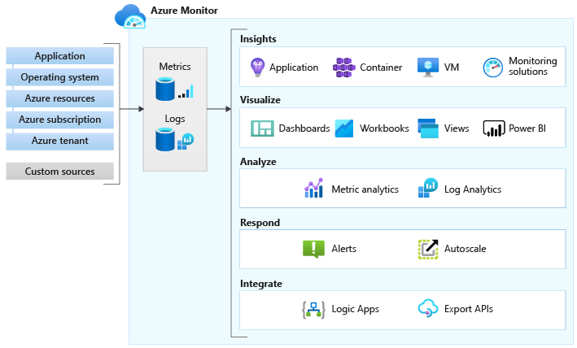

**1. Create a Log Analytics Workspace.**

- We have to create the workspace first, by searching for Log Analytics Workspace in the Azure Portal search bar and selecting the + Create button on the left side of the screen:

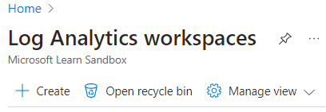

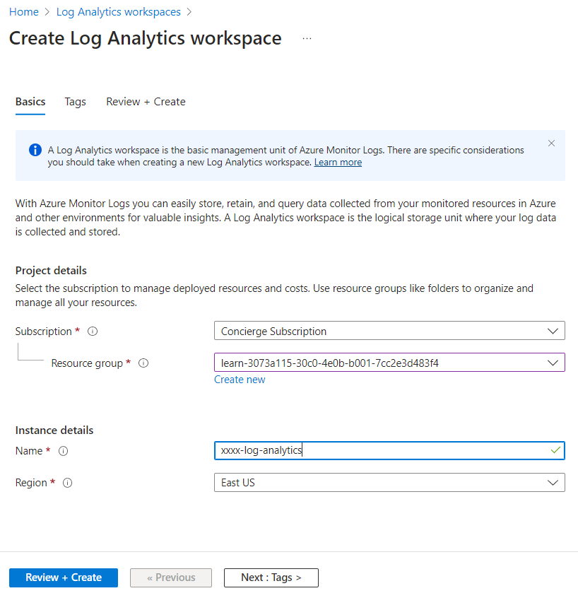

- After it’s created, we select it and go into it’s General -> Properties:

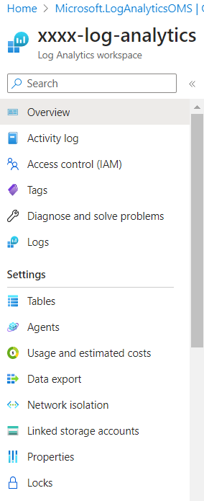

- And set the correct Access control mode:

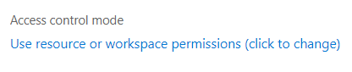

**2. Set up the environment.**

- we run the 2 bash commands in the Cloud shell here in order to create 2 virtual machines.

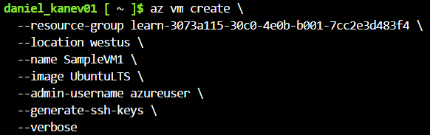

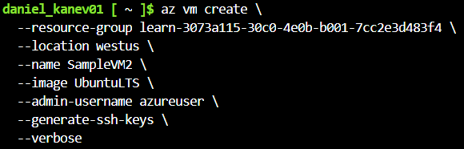

**3. Onboard virtual machines to Azure Monitor VM Insights.**

- Now from the Virtual machines in the Azure portal, we select SampleVM1.

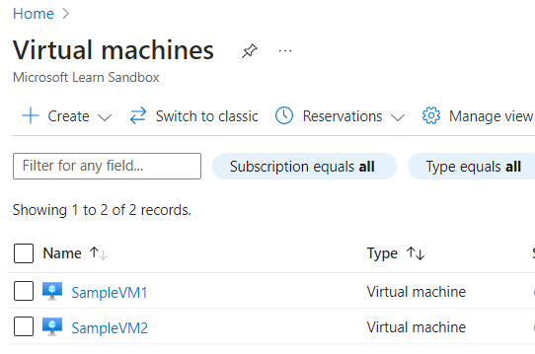

- On the left side in Monitoring -> Insights and select Enable:

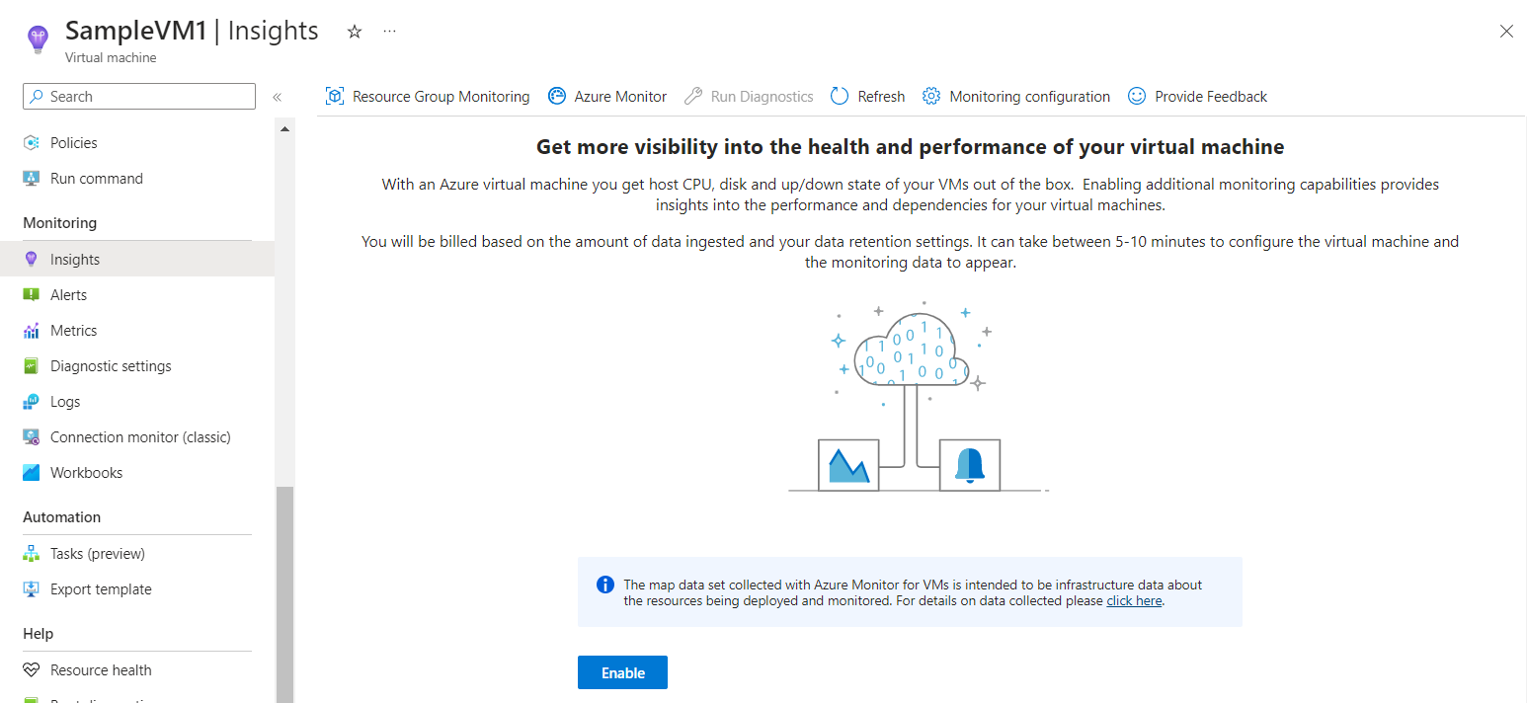

- And we select our configuration that we created earlier (repeat same steps for SampleVM2):

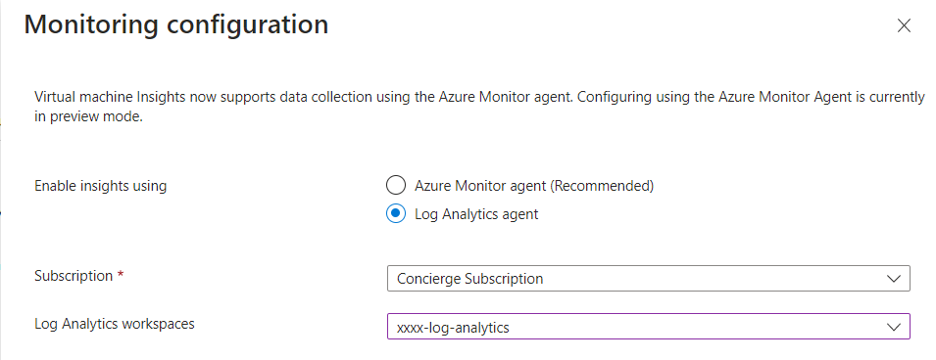

- We can now see the Map for VM1:

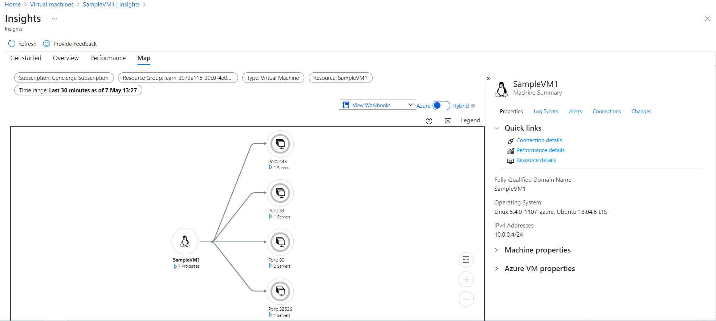

- And it’s Performance:

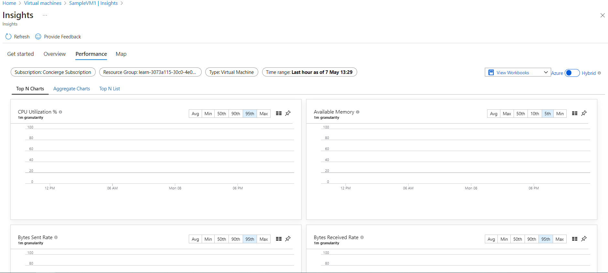

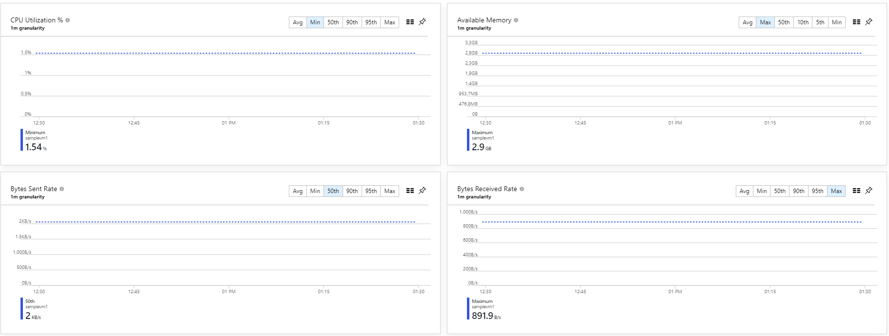

- Next, we can check its Log Event through here (while being on the Map tab):

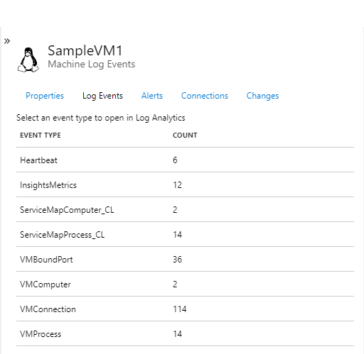

- And select InsightsMetrics, we can see the data being collected:

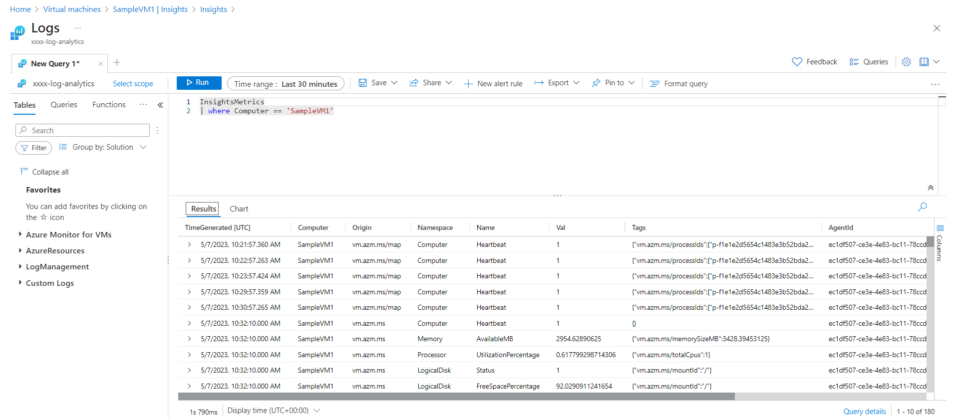

**Below is the information for the second virtual machine, SampleVM2.**

- Its Map:

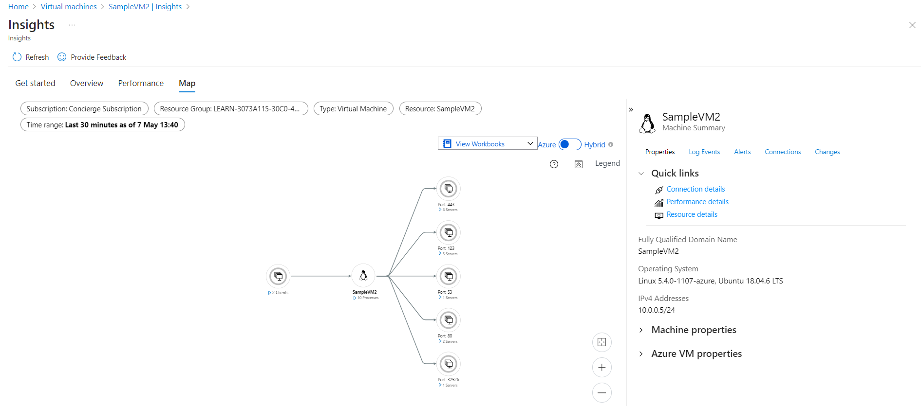

- Performance:

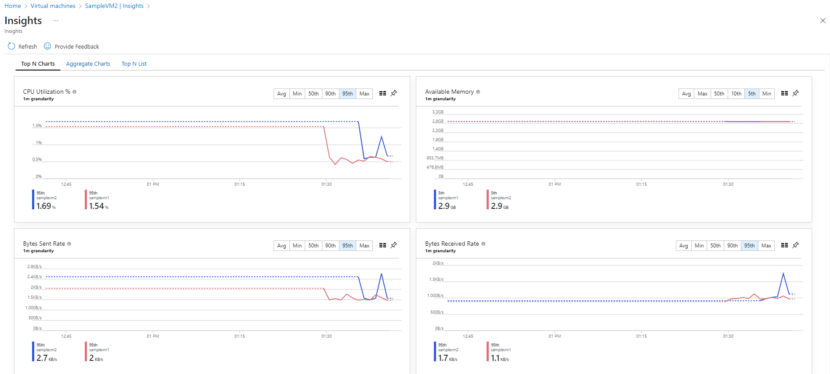

- And the Log Events:

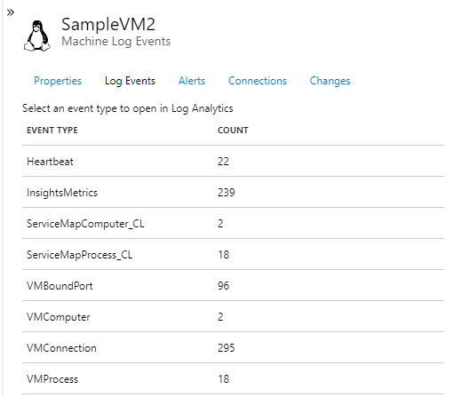

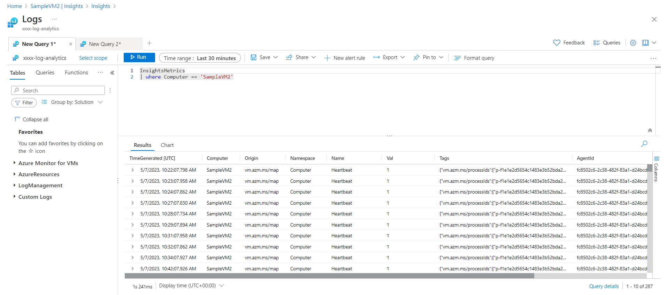

**4. Log queries.**

- The avg (Val) query:

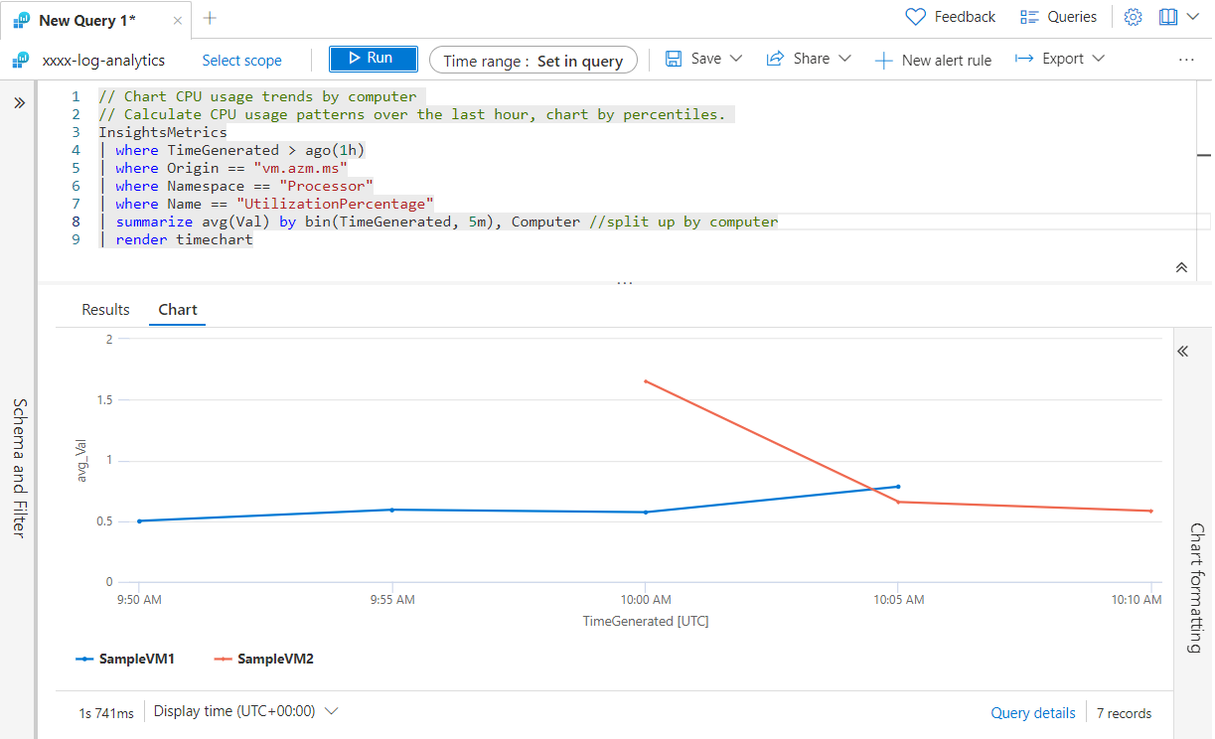

- The max (Val) query: